1. public static void main(String[ ] args) {

      int x = 5;

      while (x > 1) {

          x = x + 1;

          if (x < 3) {

          System.out.println(“small x”);

          }

      }

 }

**Output:** This Program is does not compile because we need to define the class name.

1. class Digit {

      public static void main(String[ ] args) {

                                   int x = 1;

                                   while (x < 10) {

                              if (x > 3) {

                                   System.out.println(“big x”);

                             }

                        }

                 }

            }

**Output:** Compiled. But it does not give any output because it is infinite loop.

1. class Loop {

                  int x = 5;

                             while (x  > 1) {

                                   x = x - 1;

                        if (x < 3) {

                              System.out.println(“small x”);

                        }

                   }

             }

**Output:** Does not compile. This program required Main method.

1. public class Main {

public static void main(String[] Strings) {

System.out.println("Hello world");

System.out.println("It's been nice knowing you");

System.out.println("Goodbye world");

}

}

**Output:**

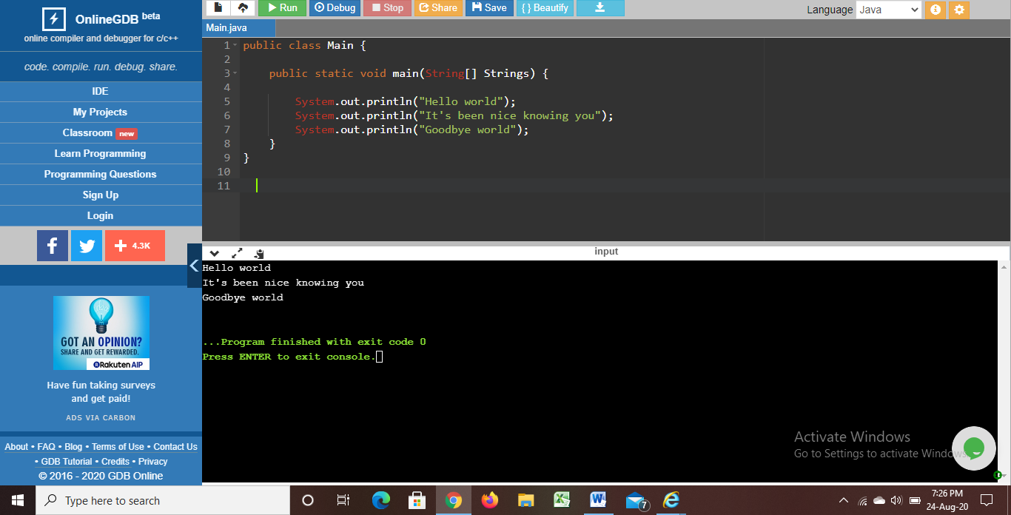

1. public class Main

{

public static void main(String[] args) {

System.out.println("Hello");

System.out.println("Jhansi");

}

}

**Output:**

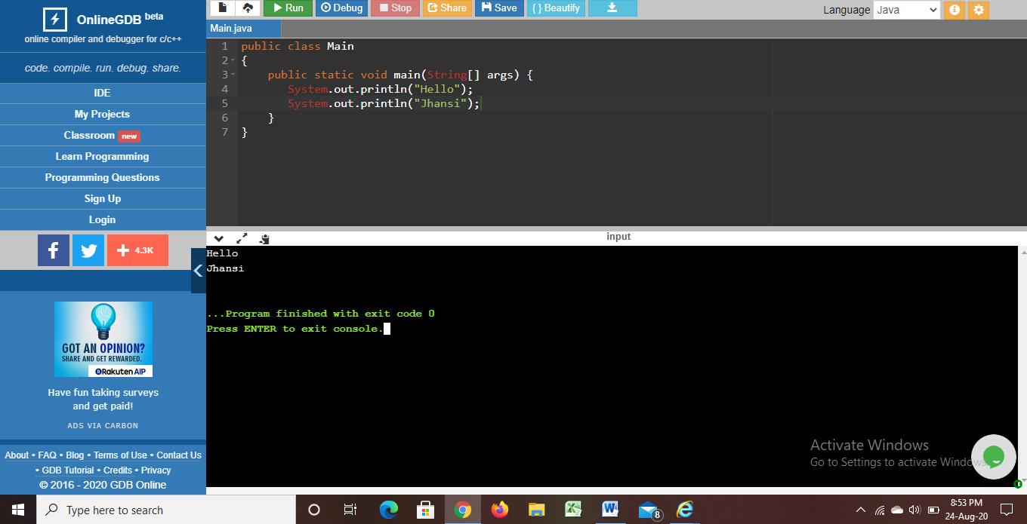

1. public class Main

{

public static void main(String[] args) {

int i;

for(i=0;i<=36;i++)

System.out.println(i);

}

}

**Output:**

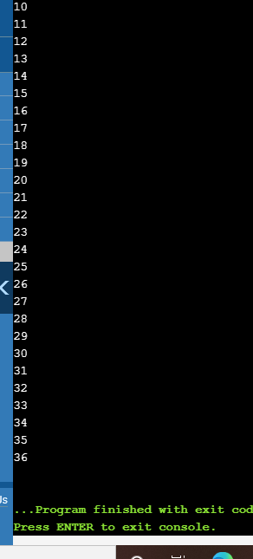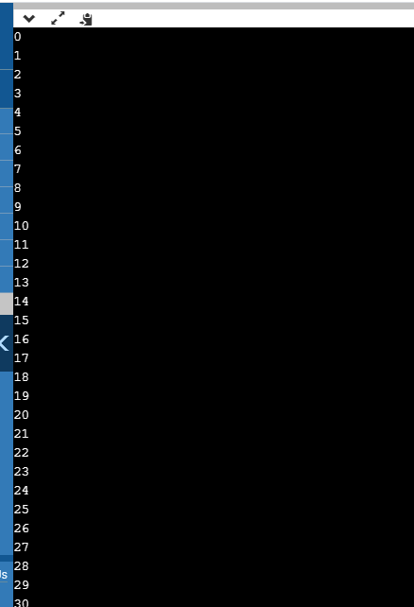

1. public class Main{

public static void main(String[] args){

double inches=Integer.parseInt(args[0]);

System.out.println(“No of inches: ”+inches);

Double centimeters=2.54*inches;

System.out.println(centimeters);

}

}

**Output:**

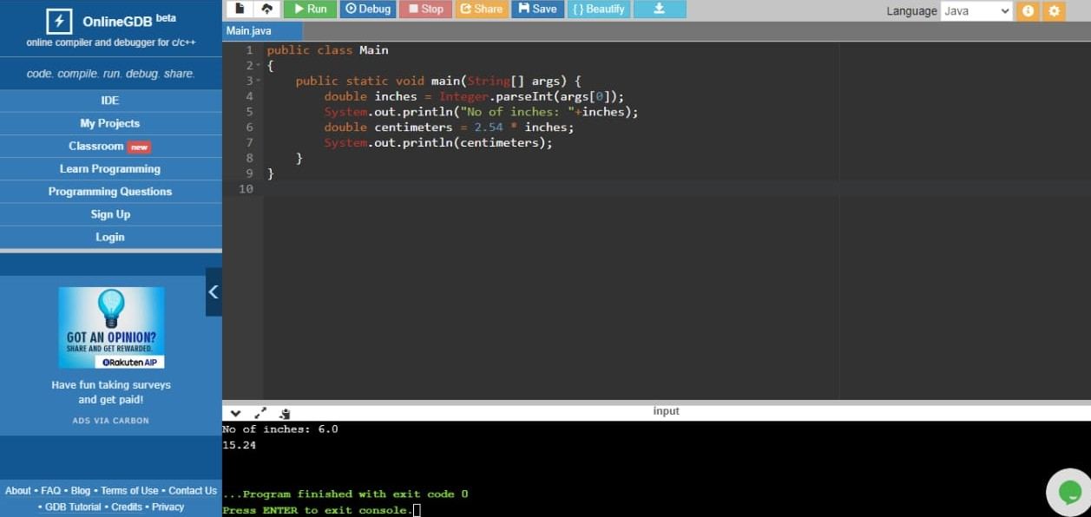

1. public class Main{

public static void main(String[] args){

int workingHours=Integer.parseInt(args[0]);

int basePayRate=Integer.parseInt(args[1]);

int total=workingHours*basePayRate;

System.out.println(total);

}

}

**Output:**

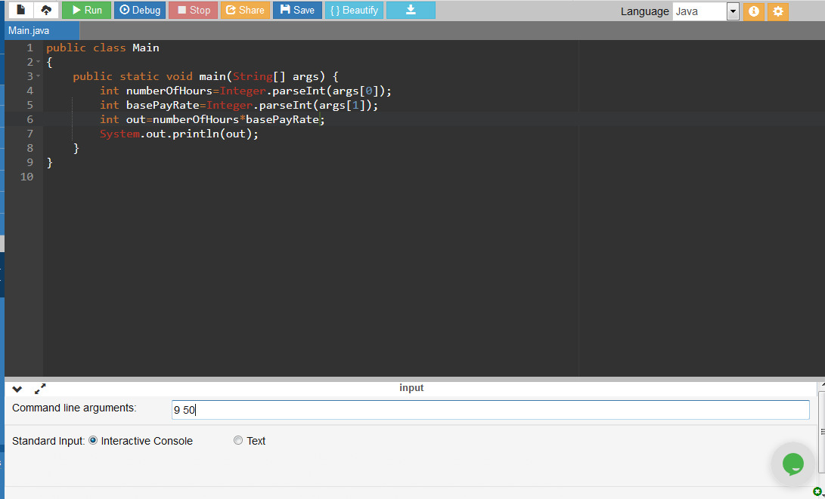

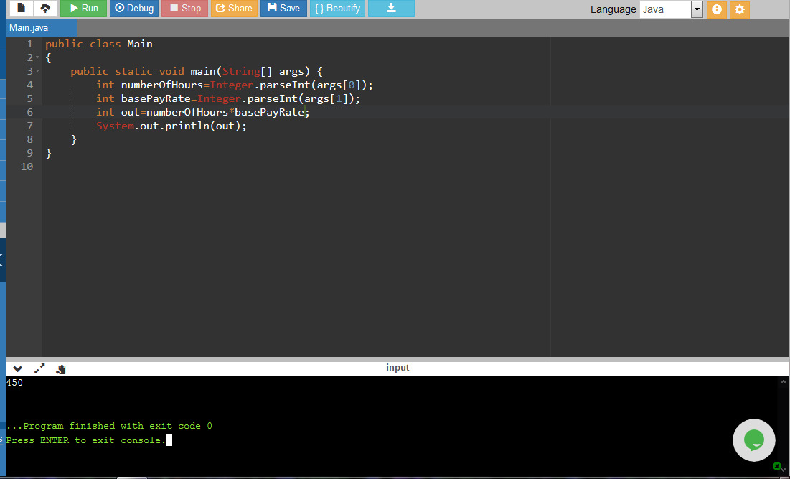

1. public class Main

{

public static void printTriagle(int n)

{

for(int i=0;i<4;i++)

System.out.println("*****");

for (int i=0; i<n; i++)

{

for (int j=n-i; j>1; j--)

{

System.out.print(" ");

}

for (int j=0; j<=i; j++ )

{

System.out.print("* ");

}

System.out.println();

}

}

public static void main(String args[])

{

int n = 4;

printTriagle(n);

}

}

**Output:**

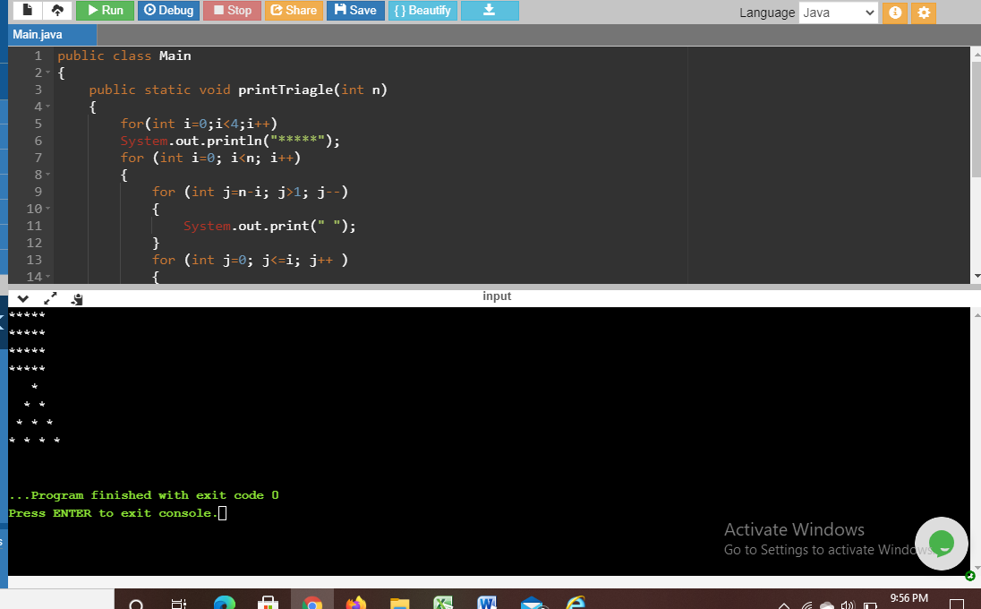

1. // This is the Hello Rank program in Java

class HelloRank {

      public static void main (String args[ ]) {

                    String name = "Rank";

                    /* Now let's say hello */

                   System.out.println("Hello + name");

                    }

}

**Output:**

Hello + name

1. // This is the Hello program in Java

class Hello {

      public static void main (String args[ ]) {

                    int i;

                    System.out.print("Hello ");       // Say Hello

               i = 0;                               // Initialize loop counter

                       while (i <= args.length) {    // Test and Loop

                    System.out.print(args[i] + " ");

                     i = i + 1;                     // Increment Loop Counter

                     }

                        System.out.println();             // Finish the line

         }

}

**Output:**

Hello exception in thread “main” java.lang.ArrayindexOutOfBoundException

1. import java.util.*;  
   public class Area {  
         public static void main(String[ ] args){  
             double a;  
       double r;  
       final double pi = Math.PI;  
     
       r = 1.0;  
       a = pi * r * r;  
       display(r,a);  
     
       r = 1.5;  
       a = pi * r * r;  
       display(r,a);  
     
       r = 2.0;  
        a = pi * r * r;  
       display(r,a);  
         }//end main  
         //-------------------------------------------//  
         static void display(double r, double a){  
              System.out.println("For radius = " + r +  
                                   ", area = " + a);  
         }//end print  
   }//end Area class

**Output:**

For radius=1.5, area=7.06858

For radius=2.0, area=12.5663

1. class Hexy {

    public static void main (String[] args)    {

         Integer i = 42;

         String s = (i<40)?"life"i>50)?"universe":"everything";

         System.out.println(s);

     }

}

A.    null

B.    life

C.    universe

D.    everything

E.    Compilation fails

F.    An exception is thrown at runtime.

**Output:** everything

This is a ternary nested loop.